

Story 4

Transportation acceleration

Version 0.1

27.11.2005

Your partner to set your business into real-time

Inhaltsverzeichnis

Story 4 1
Abbildungsverzeichnis 2
Tabellenverzeichnis 2
1 Starting point 3
2 Preparation 3
3 The Transport 4
4 Acceptance of shipment 5
5 Conclusion 5

Abbildungsverzeichnis

Fehler! Es konnten keine Einträge für ein Abbildungsverzeichnis gefunden werden.

Tabellenverzeichnis

Fehler! Es konnten keine Einträge für ein Abbildungsverzeichnis gefunden werden.

- Starting point
The British central depot in London announces that their “Pernazal” reserve is running out of stock. They send an order requesting 5000 units of the highly temperature sensitive “Pernazal” on the November 7, 2005 – they want the delivery (if possible) at the end of the week because they expect a high demand in the near future. MediTransCare acknowledges the order and ensures that the product will arrive until November 11, 2005 in London.

Order | 07.11.2005
Delivery Date | 11.11.2005
Deadline | 11.11.2005
Product | “Pernazal”, 5000 units
(OrderReceived, OrderConfirmed)

- Preparation
The transport of the ordered goods is tendered to various carriers with the note that “Pernazal” is highly sensible against temperature variations and needs a very deep cooling temperature.
Since sufficient storage capacities are present in Vienna, the transport of the goods can be started on the next day, in order to be able to supply London as early as possible.

Departure | Central storage depot Vienna  08.11.2005
Arrival | Depot London  09.10.2005
Transportation budget | EUR 5000,--
Delivery temperature for Pernazal | MinTemp: -20  MaxTemp: -10
(ShipmentTenderIssued)

The carriers Weiss (433) and Fischer (142) have to reject the offer. The carriers would need special equipment for this transport, since “Pernazal” has to be kept at a constant deep temperature. The carrier Anger (532) possesses according containers and equipment and accepts the offer from MediTransCare.
(ShipmentTenderRejected, ShipmentTenderAccepted)

MediTransCare and the carrier Anger prepare a transportation plan together for the resupply. The route goes directly without a break from Vienna to Rotterdam. This
stage takes 12 hours to complete and needs two drivers for one truck to avoid legal breaks. The route is 1200km long and goes over good highways in Germany and Netherlands. Afterwards the truck will be loaded onto a ferry and four hours later the shipment arrives at the depot in London.

Departure | 7:00, 08.11.2005 Central storage depot Vienna
Breakpoint | approx. 20:00, 08.11.2005 in Rotterdam
Arrival | approx. 00:30, 09.10.2005 storage depot in London
(ShipmentCreated)

To ensure quality standards, like always with cooled transports, MediTransCare adds dataloggers to the shipment that logs in 60 minutes intervals the current temperature between the layered goods in the polystyrene package in order to achieve meaningful results. (DataLoggerConfigured)

The parameters for the planned transport look like as follows:

Stage 1 from Vienna to Rotterdam:
CarrierId | 532 (Anger)
TransportId | 48005
PlannedShipped | 2005-11-08T07:00:00
PlannedDelivered | 2005-11-08T19:00:00
EarlyBuffered | 2005-11-08T07:00:00
LateBuffered | 2005-11-08T20:00:00
Route | Vienna To Rotterdam
Miles | 470
PlannedFreightCosts | 2200

Stage 2 from Rotterdam to London:
CarrierId | 532 (Anger)
TransportId | 48006
PlannedShipped | 2005-11-08T21:00:00
PlannedDelivered | 2005-11-09T00:30:00
EarlyBuffered | 2005-11-08T19:00:00
LateBuffered | 2005-11-11T01:00:00
Route | Rotterdam To London
Miles | 250
PlannedFreightCosts | 1500
(ShipmentCreated)

- The Transport

With a slight delay the transport goes out on the November 8, 2005 at 07:30 in the morning from the central storage depot in Vienna. Nearby Munich the carrier gets a message that the ferry companies started a strike.

Without further ado MediTransCare creates a new plan that diverts the truck to the Munich airport. A scheduled Lufthansa cargo plane (733) takes over the supply and flies it to London. This decision had to be made because of the uncertain period of the ferry strike.

The much cheaper alternative would be to divert the transport to France and to take the ferry there. This would result in far late delivery, because the drivers would have to take legal breaks. Furthermore the quality could not be secured because the dataloggers have a preconfigured measure period and only limited memory capacity.

Departure | 12:00, 08.11.2005 Airport Munich
Breakpoint | ca. 13:30, 08.11.2005 Airport Heathrow
Arrival | ca. 14:30, 09.10.2005 Storage depot in London

MediTransCare (001) will take over the transport from Heathrow to the storage depot London because they own adequate vehicles for short distances. (TransportStart, TransportEnd, DataLoggerRead, ShipmentAudit)

The parameters for the planned transport look like as follows:

CarrierId | 532 (Anger)
TransportId | 48007
PlannedShipped | 2005-11-08T12:00:00
PlannedDelivered | 2005-11-08T13:30:00
EarlyBuffered | 2005-11-08T12:00:00
LateBuffered | 2005-11-11T16:00:00
Route | Munich To London
Miles | 430
PlannedFreightCosts | 5200

- Acceptance of shipment

In London the supply is unpacked and the dataloggers are evaluated. The quality check ensures an outstanding quality of the goods. The delivered units of “Pernazal” were complete and perfectly cooled with no significant temperature fluctuations occurred.
(DataLoggerRead, ShipmentAudit)

The result of this delivery is that the shipment arrived faster than planned, but MediTransCare exceeded the transportation budget to guarantee an in-time delivery.
(ShipmentDelivered)

- Conclusion

The system can point out that something is wrong with the transportation. It could automatically generate alternative routes. For example it could recognize that a scheduled cargo machine is not fully utilized at the Munich airport heading towards the desired destination. It could calculate and recommend alternative routes together with the additional costs.
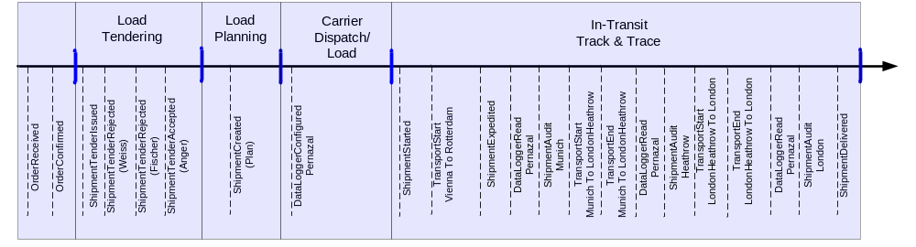
DeliveryDate
Transport
Munich - London
…
OrderReceived
Strike
Transport
Vienna - Rotterdam
Rerouting
to Munich

planned Deliverdate

